Assignment-1

Connect and disconnect with login Access

1. What happens when you login a non-existent users or username?

Provide Screenshot and What you understand, explain in short brief?

**Explanation**: User will login with their personal settings and files.

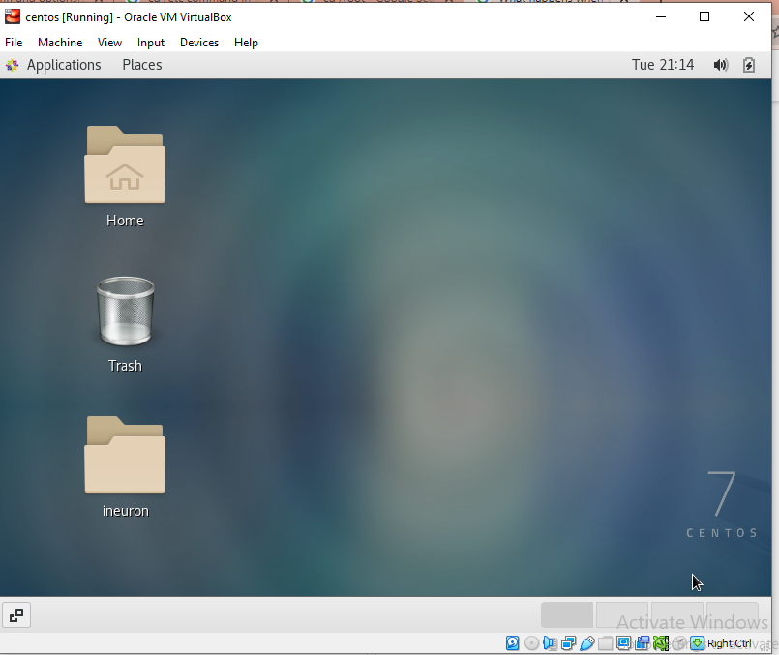

Assignment-2

Password changing

1. Login into your account and then change password?

**Explanation**: The user is first prompted the old password. This password is then hashed (encrypted) and is accessible only to the root user and compared against the stored password in the [/etc/shadow](https://www.cyberciti.biz/faq/understanding-etcshadow-file/?utm_source=Linux_Unix_File&utm_medium=faq&utm_campaign=nixfile" \o "Understanding /etc/shadow file format on Linux).Then prompted new password to enter and then prompted retype new password and at last new password is saved successfully.

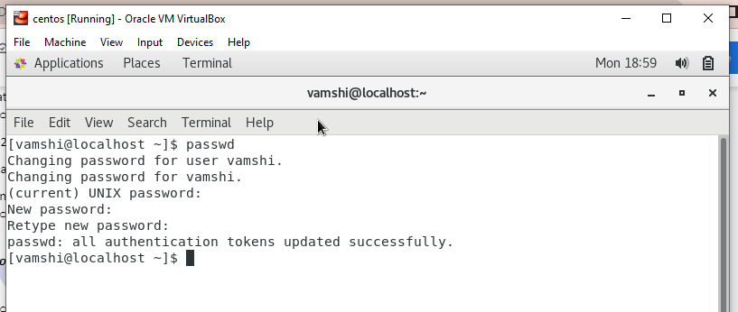

1. Try again to change password but use like password ***1234*** or ***abcd***

**Explanation**: The password is too short so need to give strong password with special characters and numbers.

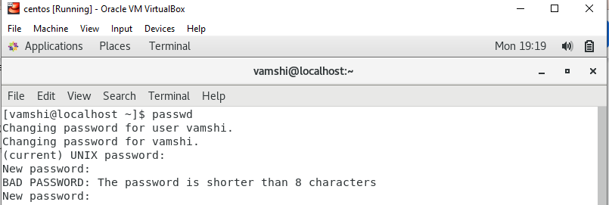

1. Try again to change password but now don’t use any password just hit **Enter** key

**Explanation**: Its showing no password supplied, so something must and should enter the password to change.

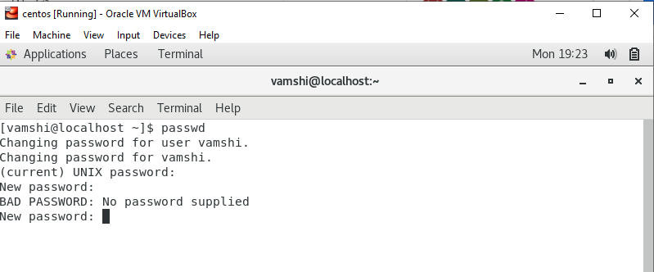

Assignment-3

Working with Directories

1. Enter the command **cd /** and then **ls** and then hit **Enter** key

**Explanation:** This command take you the top most of the root directory and listed all the directories under the root.

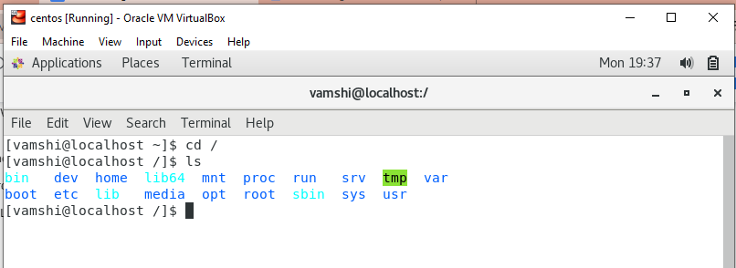

1. Enter the command now **cd /home** and then hit **Enter** key

**Explanation:**The home directory is **a directory for a particular user of the system.** With the home directory the user can store all their personal information, files, login scripts, and user information.

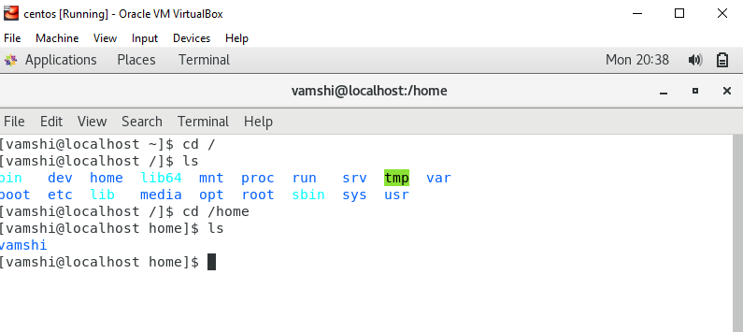

1. Enter **cd ..** and hit

**Explanation:**  It is used to change current working directory. Its step back from present current working directory.

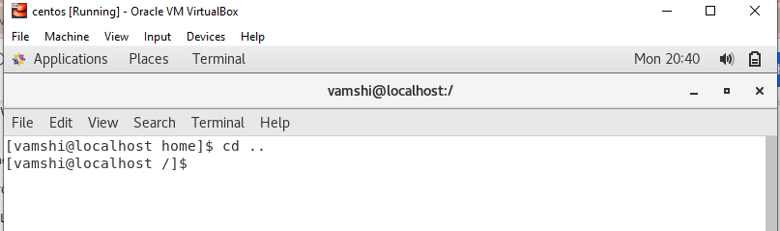

1. Now enter **cd /var/www/html** and then type **cd** and hit **Enter** key

**Explanation:** Its heading back to the home directory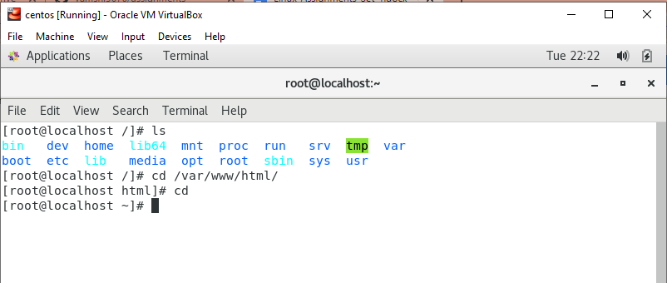

1. Now type **cd /root** and then hit **Enter** key

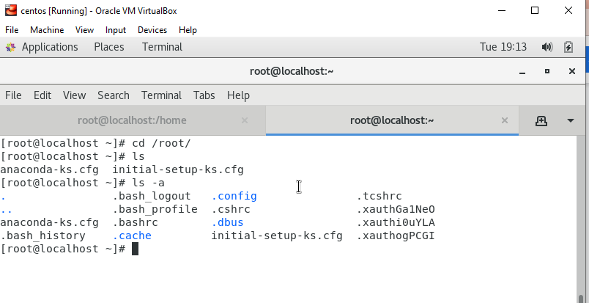

Assignment-4

Working with File Listing

1. Go to **cd /etc** and type **ls**

Take screenshot and explain what files you have seeing?

Explanation: The /etc directory **contains system configuration information**.

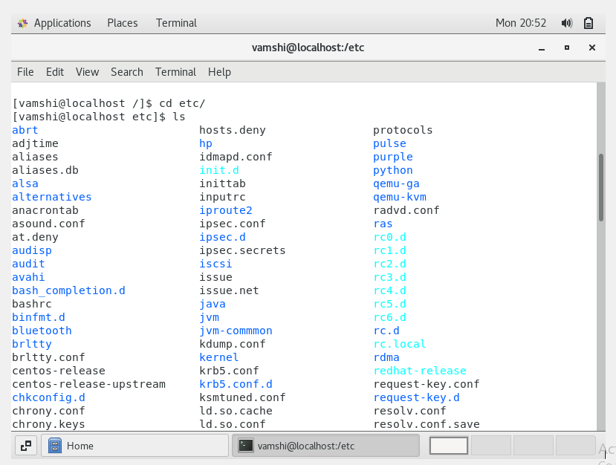

1. Then type **ls -al** and hit **Enter** key

**Explanation:** Its signifies the **long list format**. This shows a lot more information presented to the user than the standard command. You will see the file permissions, the number of links, owner name, owner group, file size, time of last modification, and the file or directory name

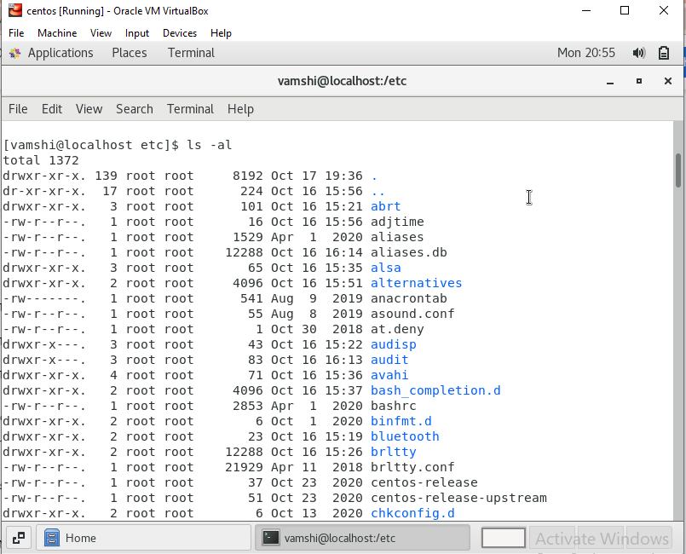

\

1. Then use **ls -i** and hit **Enter** key

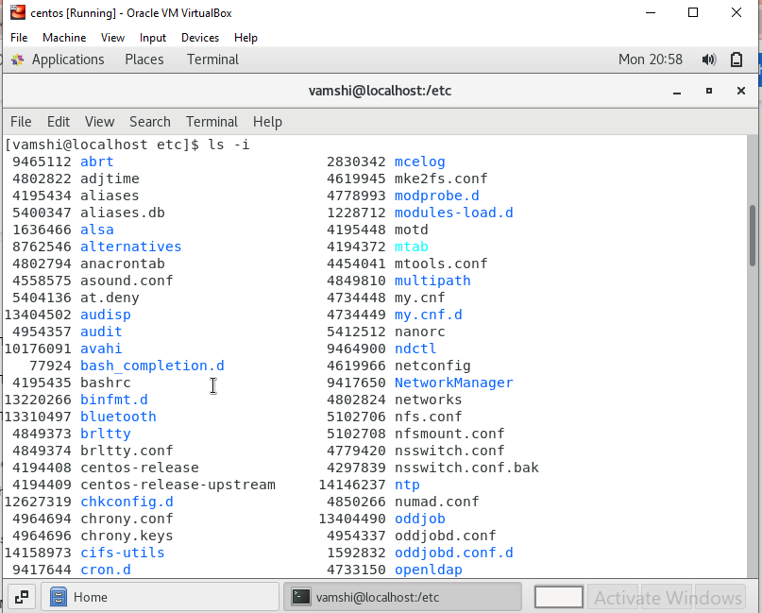

1. Then use **ls –help** and see other options about **ls** command

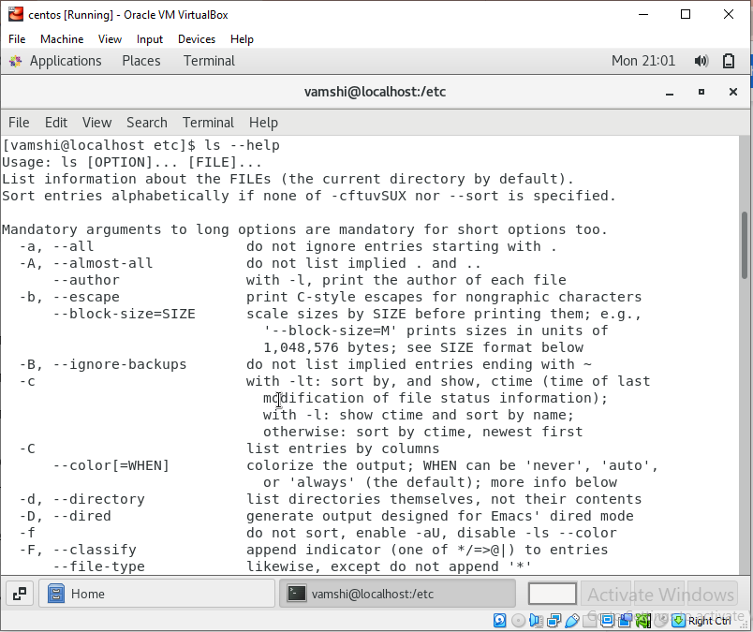

Assignment-5

Know where you are and where you working

1. Open terminal after restart the linux

check which location you working, type **pwd** and take screenshot

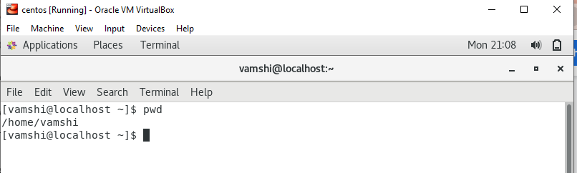

1. Now use **cd /var** and hit **Enter** key

Do **ls,** and see what output comes, give screenshot?

